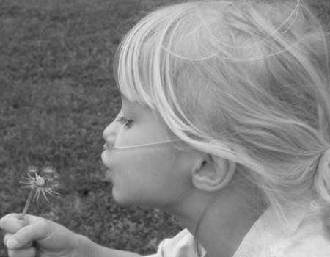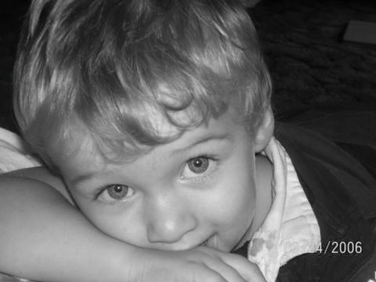

chILD Foundation

Board Recruitment Packet

2013-2014

(405)-550-2979

• www.child-foundation.com•

Table of Contents

**Mission statement & history 3**

**Board expectations 4**

**board responsibilities 5**

**board application 6-8**

**sample board member agreement 9**

**election process 10**

**Current 990 tax documents available upon request**

Mission Statement

**Our mission is to accelerate research to cure all forms of Children’s Interstitial and Diffuse Lung Disease (chILD) and to provide compassionate support, education, and hope to children and families affected by these life-altering diseases.**

“

**HOPE**

”

History of chILD

One dedicated doctor and five committed families established the Children’s Interstitial Lung Disease Foundation on March 27th 2004.

These five families were invited to the first chILD medical conference. Today, the chILD Foundation continues its work to carry out its mission. Sadly, there are many more chILD families. But, as these new families have worked together with the foundation, they have found support, answers to their questions and hope that future research will find successful treatments and, ultimately, cures for their children. The chILD Foundation is proud to report that with the donations from friends and family members, we have begun a research program. Since 2010, the foundation has co-sponsored over $150,000 in research grants with the American Thoracic Society.

Board Expectations

Board members of this organization are expected to…

* Commit to the mission and goals of the Foundation.
* Govern and manage the business of the organization
* Attend at least 75% of the Board Meetings by phone or computer (6-12 per year)
* Serve on at least one committee
* Develop funding support
* Make an annual personal contribution
* Attend a Foundation event like the annual conference or a local fundraiser
* Disclose any potential conflicts of interest

Meaning of Pinwheel

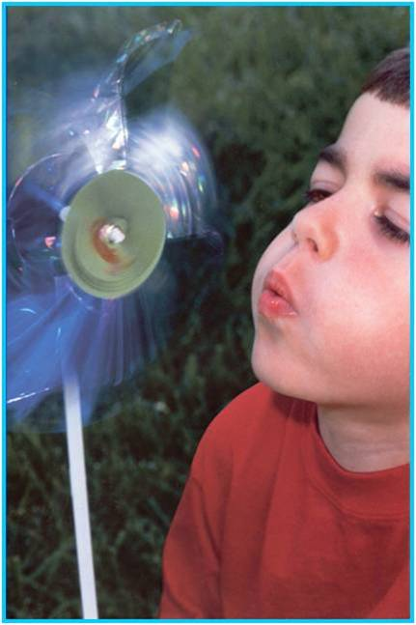

The pinwheel symbolizes air flowing freely, an iconic children’s toy gloriously whirling on a gust from the lungs of a child who could finally breathe.

Board Responsibilities

The selection of new members will depend upon the availability of a position on the Board of Directors. The chILD Foundation’s goal is to select individuals with good standing in the community. We will strive to elect chILD Foundation Board members with respect to our core values, mission and vision.

board application

**Applicants for chILD Foundation Board membership are required to complete the following application and return it to The chILD Foundation 1129 Robinhood Lane Norman, OK 73072**

**Or by e-mail to Ann Gettys at** [**agettys@child-foundation.com**](mailto:agettys@child-foundation.com)

**There is also a fill-in PDF form found at the following link: WILL ADD LINK ASAP!**

|  |  |  |  |  |  |  |  |  |  |  |  |  |
| --- | --- | --- | --- | --- | --- | --- | --- | --- | --- | --- | --- | --- |
| Name | | | | | | | Work Place | | | | | |
| Address | | | | | | | Position | | | | | |
| City | State | | | Zip | | | Address | | | | | |
| Phone | Fax | | | | | | City | | | State | | Zip |
| Email | | | | | | | Wk. Phone | | | Wk. Fax | | |
|  | | | | | | | Wk. Email (if different) | | | | | |
| 1. Please attach a brief resume to this application. | | | | | | |  | | | | | |
| 1. Explain why you wish to join the chILD Foundation and actively participate in its functions. | | | | | | | | | | | | |
| **3.** What special knowledge/qualities/expertise do you bring to The chILD Foundation that would help to support the goals and mission of the Foundation? | | | | | | | | | | | | |
| **4.** How have you previously contributed to The chILD Foundation (financially, volunteer work, fund-raising, raise awareness, etc.)? | | | | | | | | | | | | |
|  | | | | | | | | | | | | |
| **5.** Give details of current knowledge of chILD Foundation-related activities. | | | | | | | | | | | | |
| **6.** Please list your involvement in other organizations:  Past Present . | | | | | | | | | | | | |
| **7.** Are you involved in any activities that could be construed as a conflict of interest?  No  Yes If yes, explain: | | | | | | | | | | | | |
| **8**. Are you available for evening conference calls? Yes  No  Are you available during the daytime for calls? Yes No Please explain any limitations or restrictions: | | | | | | | | | | | | |
| **9**.Are you willing to travel to Chicago or other locations for board meetings? (Thursday or Friday evening to Sunday noon)                                Yes  No | | | | | | | | | | | | |
| **10**. **Please list two (2) additional references:** | | | | | | | | Work Place | | | | |
| Name | | | | | | | | Position | | | | |
| Address | | | | | | | | Address | | | | |
| City | | State | | | Zip | | | City | State | | Zip | |
| Phone | | Fax | | | | | | Wk. Phone | Wk. Fax | | | |
| Email | | | | | | | | Wk. Email | | | | |
|  | | | | | | | | Work Place | | | | |
| Name | | | | | | | | Position | | | | |
| Address | | | | | | | | Address | | | | |
| City | | | State | | | Zip | | City | State | | Zip | |
| Phone | | | Fax | | | | | Wk. Phone | Wk. Fax | | | |
| Email | | | | | | | | Wk. Email | | | | |

|  |
| --- |
| Additional Comments: (Optional) |

As an active board member I am willing to commit additional time as needed.

Signature of Applicant ___________________________________________________________________

**Sample Board Member Agreement**

I, _______, understand that as a member of the Board of Directors of the chILD Foundation, I have a legal and ethical responsibility to ensure that the organization does the best work possible in pursuit of its goals. I believe in the purpose and the mission of the organization, and I will act responsibly and prudently as its steward. As part of my responsibilities as a board member:

1. I will interpret the organization's work and values to the community, represent the organization, and act as a spokesperson.

2. In turn, I will interpret our constituencies' needs and values to the organization, speak out for their interests, and on their behalf, hold the organization accountable.

3. I will attend at least 75 percent of board meetings, committee meetings, and special events.

4. Each year, but no later than Thanksgiving of each year and without having to be asked, I will make a personal financial contribution at a level that is meaningful to me.

5. I will actively participate in one or more fundraising activities.

6. I will excuse myself from discussions and votes where I have a conflict of interest.

7. I will stay informed about what's going on in the organization. I will ask questions and request information. I will participate in and take responsibility for making decisions on issues, policies, and other matters. I will not stay silent if I have questions or concerns.

9. I will work in good faith with staff and other board members as partners toward achievement of our goals.

10. If I don't fulfill these commitments to the organization, I will expect the board president to call me and discuss my responsibilities with me.

In turn, the organization will be responsible to me in the following ways:

1. I will be sent, without having to request them, quarterly financial reports and an update of organizational activities that allow me to meet the "prudent person" standards of the law.

2. Opportunities will be offered to me to discuss with the executive director and the board president the organization's programs, goals, activities, and status; additionally, I can request such opportunities.

3. The organization will help me perform my duties by keeping me informed about issues in the industry and field in which we are working and by offering me opportunities for professional development as a board member.

4. Board members and staff will respond in a straightforward fashion to questions that I feel are necessary to carry out my fiscal, legal, and moral responsibilities to this organization. Board members and staff will work in good faith with me toward achievement of our goals.

5. If the organization does not fulfill its commitments to me, I can call on the board president and executive director to discuss the organization's responsibilities to me.

Signed:  by _________________________, Board Member Date ________

and by __________________________, Chair of the Board of Directors Date _______

**Procedures for Nominating and Electing New Board Members**

Election Process

1. Completed applications will be submitted to the chILD Foundation office.
2. Copies of the application will be given to the President who will forward them to the governance committee for their review, discussion and recommendations.

The Chairman of the Board will submit the recommendations of the governance committee to the full Board for a vote

Thank you!

Cannot commit to a board position?

Join a committee instead!

You can always donate at…

www.child-foundation.com